Date 9/9/21
Activity1 To work with operators
Data Sets used Samples(Product, Transaction)
- Aggregate operator into the process. Connect it to the output of Join.
- Click Aggregate to select. Make the following changes in the Parameters panel:
- Click on aggregation attributes.
- Select Customer ID in the left box and set function to count in the right box.
- Stay in this dialog and add another entry Product Name with function set to mode. Click Apply.
- Click on group by attributes. Then, select the Product ID by moving it to the right. Click Apply.
- Connect Aggregate to the result port on the right.
- Press Run to execute the process.
Statistics
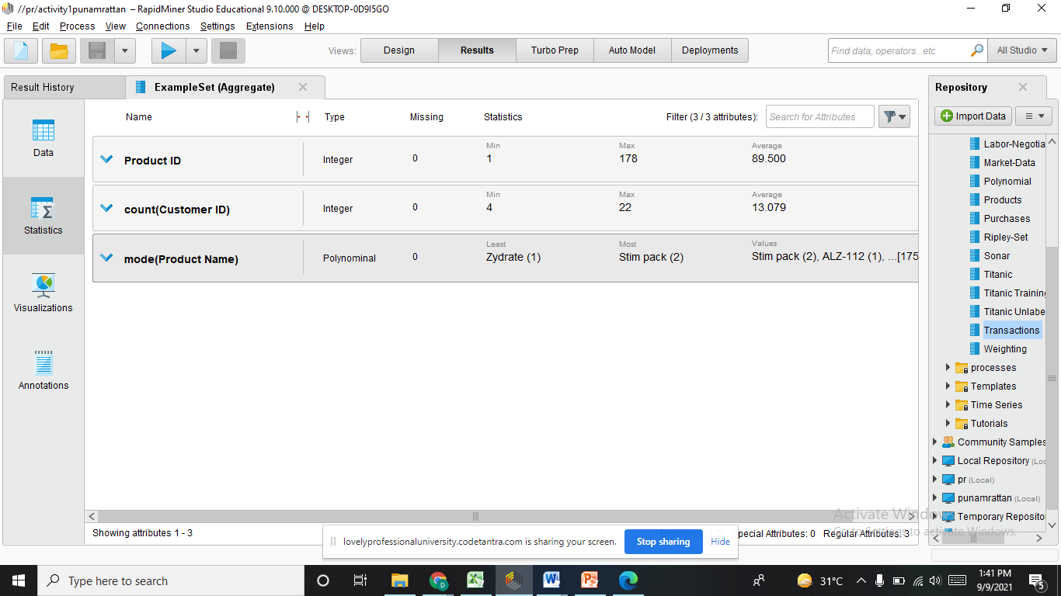
Visualization
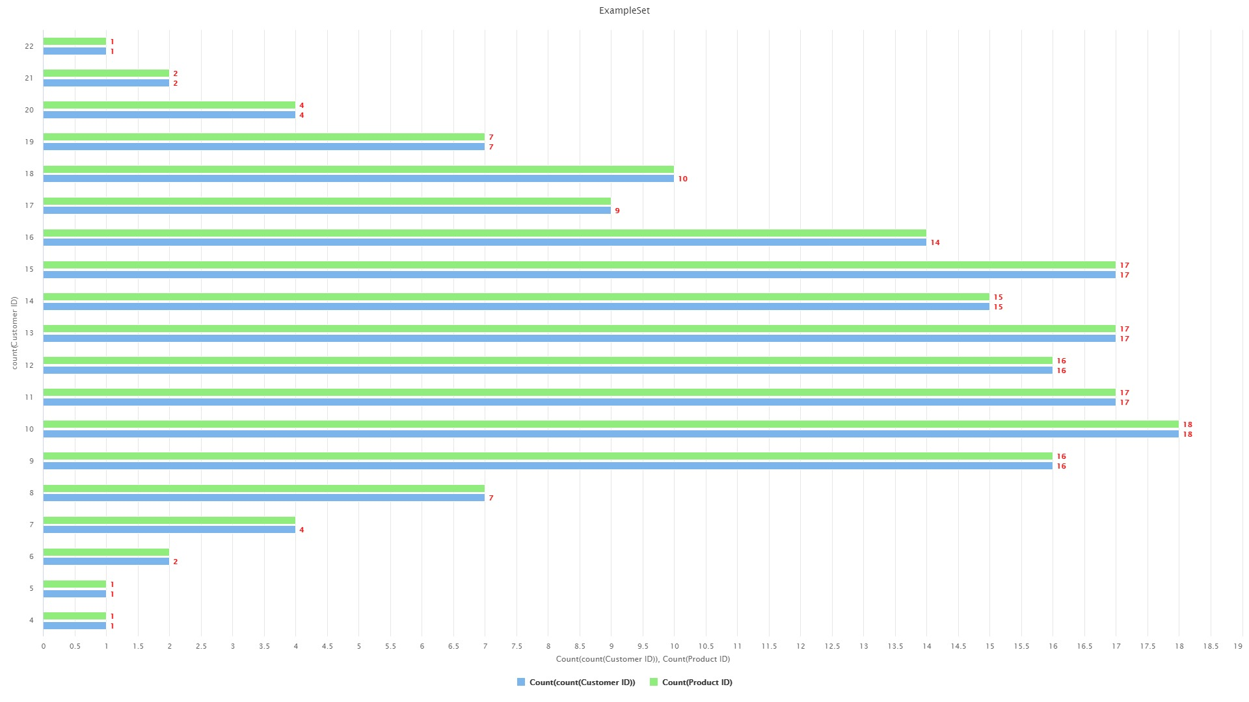
Interpretation

